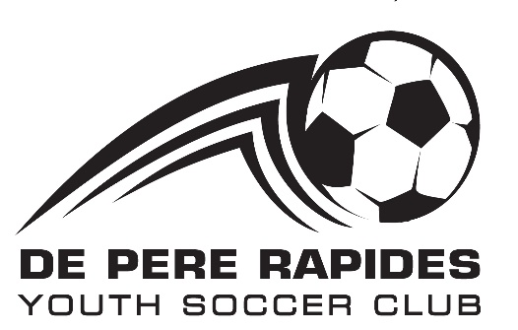

**Summer Youth Soccer League**

**De Pere & Wrightstown**

**2025 Spring/Summer Season   
 Registration Now Open!**

P.O. Box 5033, De Pere, WI 54115

[www.dprys.org](http://www.dprys.org) Voicemail: 920-785-0203 **www.dprys.org**

The De Pere Rapides Youth Soccer (DPRYS) mission is "Kids Having Fun" by providing a recreational soccer environment that they can enjoy learning the game and are guaranteed playing time in at least 50% of the game. No tryouts required.

Season begins with practices in May followed with games in June and July. Play 2 times per week.

Cost is **$55 per child for ages 4 - 11** and **$65 per child for ages 12 – 18** (age as of July 31).

**The registration deadline is February 15, 2025**. If registering after the deadline, a $15 late fee will apply and space on a team is not guaranteed.

*Register early!* Some divisions do fill up by the registration deadline and you may only have option to sign up for waitlist. (If enough players are on the waitlist to create another team by the registration deadline, another team will be added.)

Play locally! Ages 4-11 play in Wrightstown and De Pere only; ages 12-18 play games at communities within Brown County.

Non-fundraising club.

The program of 1700+ players is completely run by a volunteer board and coaches. When registering, consider signing up to coach or play a role on the board. Free training is provided.

Paid referee opportunities for ages 13 and over.

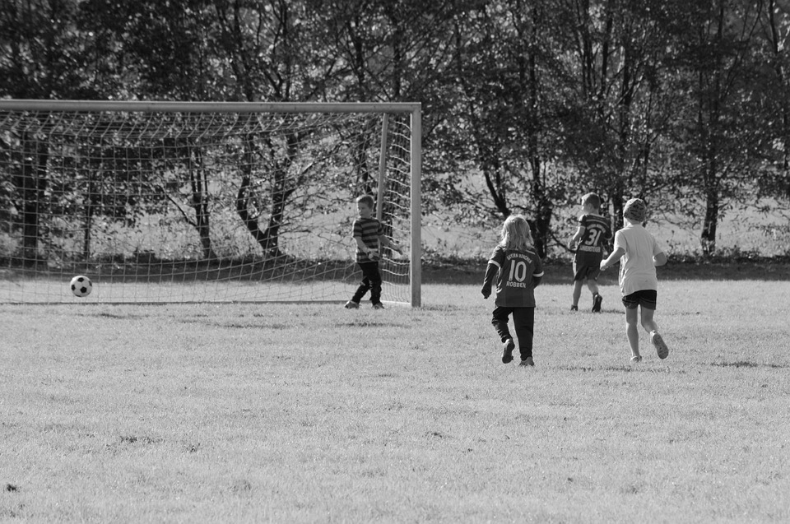See our website at [**www.dprys.org**](http://www.dprys.org) to sign up or follow us on [**Facebook**](https://www.facebook.com/depererapides) for more details.